**6. SINIF İNGİLİZCE DERSİ 2. DÖNEM 1. ORTAK YAZILI KONU SORU DAĞILIM TABLOSU SENARYO 1**

|  |  |  |
| --- | --- | --- |
| **TEMA** | **KAZANIMLAR** | **SORU SAYISI** |
| **AT THE FAIR** | E6.5.SI1. Students will be able to talk about and express the feelings and personal opinions about places and things | **1** |
| **AT THE FAIR** | E6.5.L1. Students will be able to recognize the words related to the expression of emotions | **2** |
| **AT THE FAIR** | E6.5.R1. Students will be able to understand general meaning in simple texts related to the feelings and personal opinions about places and things. | **1** |
| **OCCUPATIONS** | E6.6.L1. Students will be able to understand familiar words and simple phrases concerning people’s occupations in clear oral texts. | **2** |
| **OCCUPATIONS** | E6.6.SI1. Students will be able to talk about occupations. | **2** |

**6. SINIF İNGİLİZCE DERSİ 2. DÖNEM 1. ORTAK YAZILI KONU SORU DAĞILIM TABLOSU SENARYO 2**

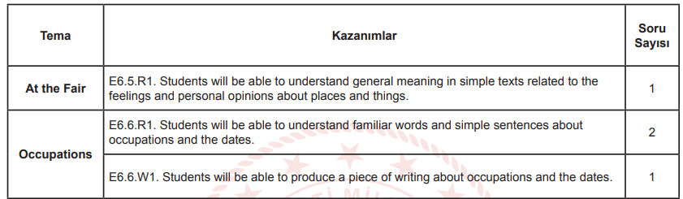

**6. SINIF İNGİLİZCE DERSİ 2. DÖNEM 1. ORTAK YAZILI KONU SORU DAĞILIM TABLOSU SENARYO 3**

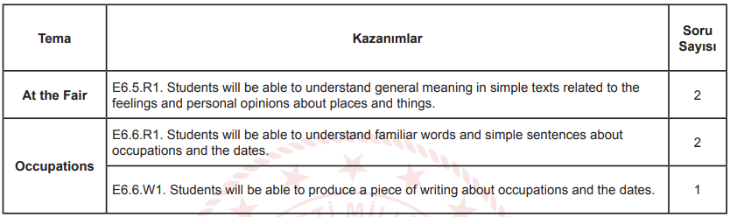

**6. SINIF İNGİLİZCE DERSİ 2. DÖNEM 1. ORTAK YAZILI KONU SORU DAĞILIM TABLOSU SENARYO 4**

|  |  |  |
| --- | --- | --- |
| **TEMA** | **KAZANIMLAR** | **SORU SAYISI** |
| **AT THE FAIR** | E6.5.SI1. Students will be able to talk about and express the feelings and personal opinions about places and things. | **2** |
| **AT THE FAIR** | E6.5.SP1. Students will be able to use various simple expressions to state the feelings and personal opinions about places and things | **1** |
| **OCCUPATIONS** | E6.6.R1. Students will be able to understand familiar words and simple sentences about occupations and the dates | **2** |
| OCCUPATIONS | E6.6.W1. Students will be able to produce a piece of writing about occupations and the dates. | 1 |

**6. SINIF İNGİLİZCE DERSİ 2. DÖNEM 1. ORTAK YAZILI KONU SORU DAĞILIM TABLOSU SENARYO 5**

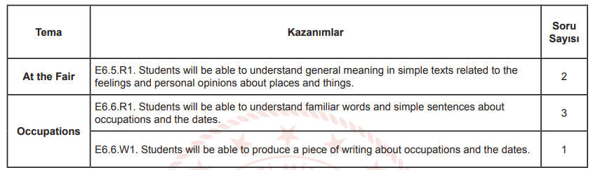

**6. SINIF İNGİLİZCE DERSİ 2. DÖNEM 1. ORTAK YAZILI KONU SORU DAĞILIM TABLOSU SENARYO 6**

