**7. SINIF İNGİLİZCE DERSİ 2. DÖNEM 1. ORTAK YAZILI KONU SORU DAĞILIM TABLOSU SENARYO 1**

|  |  |  |
| --- | --- | --- |
| **TEMA** | **KAZANIMLAR** | **SORU SAYISI** |
| **TELEVISION** | E7.5.R2. Students will be able to understand simple texts about past events. | **1** |
| **TELEVISION** | E7.5.W1. Students will be able to write pieces about daily routines and preferences | **2** |
| **CELEBRATIONS** | E7.6.R1. Students will be able to understand texts about celebrations. | **1** |
| **CELEBRATIONS** | E7.6.W1. Students will be able to write invitation cards | **2** |

**7. SINIF İNGİLİZCE DERSİ 2. DÖNEM 1. ORTAK YAZILI KONU SORU DAĞILIM TABLOSU SENARYO 2**

|  |  |  |
| --- | --- | --- |
| **TEMA** | **KAZANIMLAR** | **SORU SAYISI** |
| **TELEVISION** | E7.5.R2. Students will be able to understand simple texts about past events. | **2** |
| **TELEVISION** | E7.5.W1. Students will be able to write pieces about daily routines and preferences | **1** |
| **CELEBRATIONS** | E7.6.R1. Students will be able to understand texts about celebrations. | **1** |
| **CELEBRATIONS** | E7.6.W1. Students will be able to write invitation cards | **2** |

**7. SINIF İNGİLİZCE DERSİ 2. DÖNEM 1. ORTAK YAZILI KONU SORU DAĞILIM TABLOSU SENARYO 3**

|  |  |  |
| --- | --- | --- |
| **TEMA** | **KAZANIMLAR** | **SORU SAYISI** |
| **TELEVISION** | E7.5.R2. Students will be able to understand simple texts about past events. | **2** |
| **TELEVISION** | E7.5.W1. Students will be able to write pieces about daily routines and preferences. | **2** |
| **CELEBRATIONS** | E7.6.R1. Students will be able to understand texts about celebrations. | **2** |

**7. SINIF İNGİLİZCE DERSİ 2. DÖNEM 1. ORTAK YAZILI KONU SORU DAĞILIM TABLOSU SENARYO 4**

|  |  |  |
| --- | --- | --- |
| **TEMA** | **KAZANIMLAR** | **SORU SAYISI** |
| **TELEVISION** | E7.5.R1. Students will be able to understand simple texts about daily routines and preferences. | **2** |
| **TELEVISION** | E7.5.R2. Students will be able to understand simple texts about past events.. | **1** |
| **TELEVISION** | E7.5.W1. Students will be able to write pieces about daily routines and preferences | **1** |
| **CELEBRATIONS** | E7.6.R1. Students will be able to understand texts about celebrations. | **3** |

**7. SINIF İNGİLİZCE DERSİ 2. DÖNEM 1. ORTAK YAZILI KONU SORU DAĞILIM TABLOSU SENARYO 5**

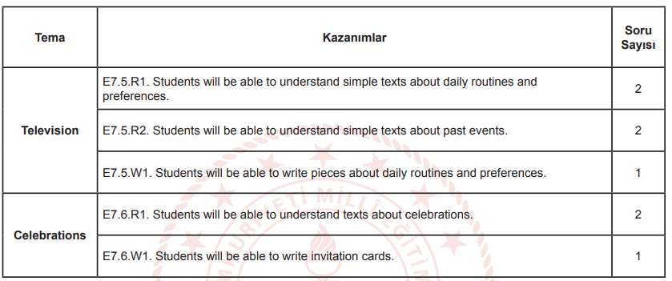

**7. SINIF İNGİLİZCE DERSİ 2. DÖNEM 1. ORTAK YAZILI KONU SORU DAĞILIM TABLOSU SENARYO 6**

